Enduring Issues Essay
Enduring Issues Essay Prompt
The prompt will be the same every time

An enduring issue is an issue that exists across time. It is one that many societies have attempted to address with varying degrees of success.

In your essay
- Identify and define an enduring issue raised by this set of documents.
- Using your knowledge of Social Studies and evidence from the documents, argue why the issue you selected is significant and how it has endured across time.

Be Sure to
- Identify the issue based on a historically accurate interpretation of three documents.
- Define the issue using evidence from at least three documents.
- Argue that this is a significant issue that has endured by showing:
  - How the issue has affected people or been affected by people.
  - How the issue has continued to be an issue or changed over time.

Include outside information from your knowledge of Social Studies and evidence from the documents. You will always be given 5 documents.
These nine issues commonly come up in Global History, but they are just a starting point. Choose an issue based on the documents presented, not on this list. When identifying an enduring issue be as specific as possible and try to identify causes and/or effects: Conflict, Desire for Power, Inequity, Need for and Impact of Innovation, Impact of Interconnectedness, Impact of Ideas and Beliefs, Environmental Impact, Scarcity Population Growth

Steps for Constructing an Enduring Issues Essay

- Read each document, annotate it, and identify the main idea and possible enduring issues for each document.
  - Read and annotate documents 1-5 and complete the MI, EI, OI chart

- Compare each document and the ideas in them to identify similarities and differences.

- Identify possible enduring issues that are present in more than one document and sort documents into categories based on possible enduring issues.

- Choose an enduring issue that relates to at least three documents and that you can show has endured over time.

- Reread documents related to the enduring issue.

- Refine the enduring issue and define it.

Enduring Issues Essay: In Class - Thursday, January 10th
You can use your completed outline to write the essay
Outline can be submitted for extra credit

Document 1 – The Indian Caste System
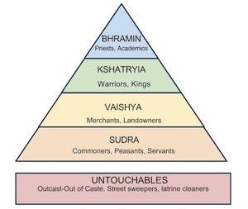

Main Idea | Enduring Issue | Outside Information

Document 2 – From the Analects of Confucius

Yu Tzu [a disciple named Yu Jo] said, “Few of those who are filial sons and respectful brothers will show disrespect to superiors, and there has never been a man who is not disrespectful to superiors, and there has never been a man who is not disrespectful to superiors and yet creates disorder….Filial piety and brotherly respect are the root of humanity.”

“Confucius said: ‘A young man should serve his parents at home and be respectful to elders outside his home. He should be earnest and truthful, loving all, but become intimate with humaneness. [Showing respect helps to create order,] After doing this, if he has energy to spare, he can study literature and the arts…. In education there should be no class distinctions.”

- From the Analects of Confucius, ~479 BCE

Main Idea | Enduring Issue | Outside Information
Document 3 – Excerpts from Pericles’ Funeral Oration (Ancient Athens)
“Our plan of government favors the many instead of the few: that is why it is called a

democracy…

As for social standing, advancement is open to everyone, according to ability. While every citizen has equal opportunity to serve the public, we reward our most distinguished citizens by asking them to make our political decisions. Nor do we discriminate against the poor. A man may serve his country no matter how low his position on the social scale.

Let me say that our system of government does not copy the institutions of our neighbors. It is more the case of our being a model to others, than of our imitating anyone else. Our constitution is called a democracy because power is in the hands not of a minority but of a whole people…

Then there is a great difference between us and our opponents, in our attitude towards military security. Here are some examples: Our city is open to the world, and we have no periodical deportations in order to prevent people observing or finding out secrets which might be of military advantage to the enemy. This is because we rely, not on secret weapons, but on our own real courage and loyalty….

Our love of what is beautiful does not lead to extravagance; our love of the things of the mind does not make us soft. We regard wealth as something to be properly used, rather than as something to boast about. As for poverty, no one need to be ashamed to admit it; the real shame is in not taking practical measures to escape from it. Here each individual is interested not only in his own affairs, but in the affairs of the state as well: even those who are mostly occupied with their own business are extremely well informed on general politics….”

Main Idea | Enduring Issue | Outside Information
Document 4 - Slavery and the Slave Trade in Rome
Slavery was an ever-present feature of the Roman world. Slaves served in households, agriculture, mines, the military, manufacturing workshops, construction and a wide range of services within the city. As many as 1 in 3 people in Italy and 1 in 5 people across the empire were slaves, and upon this foundation of forced labor was built the entire Roman state and society.

ORIGIN OF SLAVES IN THE ROMAN EMPIRE
Aside from the huge numbers of slaves taken as war captives (e.g. 75,000 from the First Punic War alone), slaves were also acquired via piracy, trade, robbery and reproduction (a child born to a slave mother (vernae) automatically became a slave irrespective of who the father was). Slave markets existed in most large towns, though, and here, in a public square, slaves were paraded with signs around their necks advertising their virtues for prospective buyers.

THE STATUS OF SLAVES
The number and proportion of slaves in society varied over time and place. A more modest Roman business owner, artisan or military veteran might own one or two slaves while for the very wealthy, the number of slaves owned could run into the hundreds. For example, in the 1st century CE, the prefect L. Pedanius Secundus had 400 slaves merely for his private residence.
Slaves had no rights at all in fact and certainly no legal status or individuality. They could not create relations or families, nor could they own property. For all intents and purposes, they were merely the property of a particular owner. Slaves were, for many of the Roman elite, a status symbol and, therefore, the more slaves one had, the better. Wealthy Romans very often appeared in public accompanied by an entourage of as many as 15 slaves.

THE ROLES OF SLAVES
Slaves were employed by private individuals or the state and worked in agriculture (especially the grain, vine and olive sectors), in mines (especially for gold and silver), manufacturing industries, transportation, education (where they brought their specialist knowledge of such topics as philosophy and medicine to the Roman world), the military (principally as baggage porters and camp assistants), the service industries (from food to accounting), in the private home, in the construction industry, on road-building projects, in public baths, and even to perform tasks in certain cult rituals.

WINNING FREEDOM
There was, at least for a small minority, the possibility of a slave achieving freedom to become a freedman or woman, and this incentive was fully exploited by slave owners. Freedom could be granted by the owner but in most cases was actually bought by the slaves themselves. Freedom could be absolute or might be limited and include certain obligations to the former owner such as inheritance rights or the payment of a portion (statuliber) of their earned assets (peculium).

Children of a freed woman would not have any limits on their rights (although social status might be affected in terms of reputation). Also, former slaves could become citizens (especially from the Augustan period) and even become slave owners themselves. One famous example was the freedman C. Caecilius Isidorus who would eventually own over 4,000 slaves. This prize of freedom and integration back into society was also used by owners and authority to convince slaves of the benefits of working hard and being obedient.

Main Idea | Enduring Issue | Outside Information
Document 5 – Hammurabi’s Code
The Code of Hammurabi was one of the first written law codes. It was written around 1754 BC by Hammurabi, the king of Babylon. It was written on a stele, or a large stone monument, and placed in a public place so that all could see it. A carving at the top of the stele shows King Hammurabi receiving the laws from the god Shamash. The inscription states that King Hammurabi was chosen by the gods of his people to bring the laws to them.  Excerpt from the first lines of the Code of Hammurabi:  When Anu the Sublime, King of the Anunaki, and Bel, the lord of Heaven and earth, who decreed the fate of the land...called Babylon by his illustrious name, made it great on earth, and founded an everlasting kingdom in it, whose foundations are laid so solidly as those of heaven and earth; then Anu and Bel called by name me, Hammurabi, the exalted prince, who feared God, to bring about the rule of righteousness in the land, to destroy the wicked and the evil-doers; so that the strong should not harm the weak; so that I should rule over the black-headed people like Shamash, and enlighten the land, to further the well-being of mankind. | 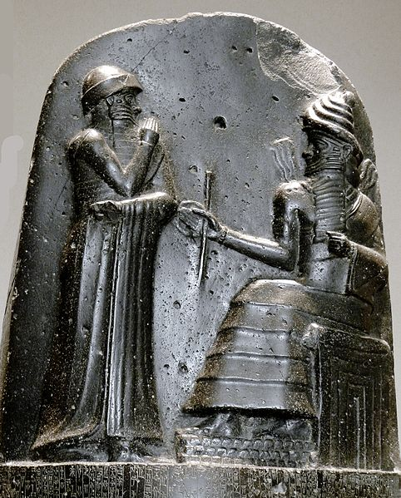  Carving on the top of a stele with the Code of Hammurabi inscribed below it.
Source: Adapted by New Visions from Hammurabi by Joshua J. Mark which is published on Ancient History Encyclopedia under the CC BY-NC-SA 3.0 Unported license.
Source: “Code of Hammurabi.” Translated by L.W. King. The Eleventh Edition of the Encyclopaedia Britannica. 1915. Found on the Fordham University’s Ancient History Sourcebook: http://www.fordham.edu/halsall/ancient/hamcode.asp

Main Idea | Enduring Issue | Outside Information

